Flight Delay Classification Report

Introduction
Flights are the foundation for global integration, strengthening social connectivity,enabling economic expansion, and ensuring access to essential services. The aviation sector promotes commerce and travel , unites families and communities across borders, and makes it easier for people to obtain humanitarian help, healthcare, and education. Therefore, proving that air travel is more than just a convenience. Air travel is a vital part of the logistical, social and economic architecture of modern society. The purpose of this experiment was to determine whether scheduled departure time, origin airport, airline carrier,destination airport, and flight distance could be utilized to predict flight delays. Ten-fold cross-validation was used to assess a J48 decision-tree classifier that was created in WEKA. Based on the planned departure time, the model generated a straightforward decision tree with an overall accuracy of 59.33%. The model's overall performance indicates that more factors are required to increase forecast accuracy, even if it showed some ability to categorize delayed flights.

Dataset Description
The data used for this analysis were collected during a biannual event called the Data Exposition . This event is a Joint Statistical Meeting where the Computing and Graphics Section of the American Statistical Association(ASA) join in sponsoring a special poster gathering . This data consists of flight arrival and departure details for all commercial flights within the USA during the year of 2007 . This dataset consists of 30 attributes and 30,000 flights .
Data Preparation
The factors important to forecasting flight delays were kept in the dataset after eliminating unnecessary features . The scheduled departure time, airline carrier, origin, destination, distance, and Delayed attributes were selected to conduct this analysis .These variables were chosen because they represent flight factors that may have an impact on the likelihood of a delay. After selecting the needed variables , an excel sheet was created that only contained 300 flights . Using 300 instances was an acceptable choice because it provided a balance between containing enough data during the training phase and evaluating the J48 decision-tree classifier while keeping the analysis manageable. Before constructing the classification model, the cleaned dataset was imported into WEKA and the Delayed attribute was designated as the class variable. The target variable in this study was the "delayed” variable ,this variable indicated whether or not a flight was delayed.

Data Analysis
The J48 decision-tree classifier was used for this analysis.With 300 observations, the model had sufficient examples to identify patterns and perform 10-fold cross-validation, where each fold contained approximately 30 instances. This allowed every observation to be used for both training and testing, producing a more reliable estimate of the model's performance than using a very small dataset.

Additionally, 300 instances reduced the likelihood that the model's results were influenced by random variation that can occur with smaller samples. Although a bigger dataset could potentially improve the model's capability to generalize, using 300 instances was enough for demonstrating the classification process . Which includes evaluating the J48 algorithm, and producing meaningful performance metrics such as accuracy, Kappa statistic, MAE, and RMSE.
In order to minimize overfitting, J48 prunes redundant branches from a decision tree while choosing the characteristics that best divide the target classes. A trustworthy estimate of the model's performance on unseen data was obtained by using each subset once for testing and the remaining subsets to train the model.

Results
The J48 classifier produced a simple decision tree with two leaves and a tree size of three. The model labeled CRSDepTime as the only variable needed for the classification. Flights with a scheduled departure time of 12:59 or earlier were considered not delayed , while flights departing time`s later than 12:59 were classified as delayed . Using the 10-fold cross-validation approach , the model correctly classified 178 of 300 flights, which is an accuracy of 59.33%. The remaining 122 flights were misclassified , resulting in an accuracy of 40.67% . The model also produced a mean absolute error (MAE) of 0.4786 , root mean squared error (RMSE) of 0.4933 and Kappa statistic of 0.0907. These metrics indicate a modest predictive performance. Although the low Kappa statistic shows that the model only marginally exceeded random categorization, these results imply that scheduled departure time may have an impact on flight delays. The model's ability to precisely forecast flight delays may be improved by adding more predictors, such as airport traffic, aircraft availability, weather,or seasonal variables.

Conclusions
The J48 decision-tree classifier showed that the main predictor of flight delays in this dataset was the scheduled departure time. Despite achieving 59.33% accuracy, the model's overall predictive performance was restricted, as shown by its low Kappa score and substantial error rates. The results indicate that flight delays are slightly impacted by departure time, but more flight and operational factors are required to create a more precise and trustworthy prediction model.

Variable Description Table

Variable | Description
Year | Year in which the flight occurred (1987–2008)
Month | Month of the flight (1–12)
DayofMonth | Day of the month (1–31)
DayOfWeek | Day of the week (1 = Monday, 7 = Sunday).
DepTime | Actual departure time (local time, HHMM)
CRSDepTime | Scheduled departure time (local time, HHMM)
ArrTime | Actual arrival time (local time, HHMM)
CRSArrTime | Scheduled arrival time (local time, HHMM)
UniqueCarrier | Airline carrier identification code.
FlightNum | Flight number assigned by the airline
TailNum | Aircraft tail number (unique aircraft identifier)
ActualElapsedTime | Total actual flight duration, in minutes
CRSElapsedTime | Scheduled flight duration, in minutes
AirTime | Time spent in the air, in minutes
ArrDelay | Arrival delay, measured in minutes
DepDelay | Departure delay, measured in minutes
Origin | IATA code of the departure airport
Dest | IATA code of the destination airport
Distance | Flight distance, in miles

TaxiIn | Taxi-in time after landing, in minutes
TaxiOut | Taxi-out time before takeoff, in minutes.
Cancelled | Indicates whether the flight was cancelled (1 = Yes, 0 = No).
CancellationCode | Reason for cancellation (A = Carrier, B = Weather, C = National Airspace System, D = Security).
Diverted | Indicates whether the flight was diverted (1 = Yes, 0 = No)
CarrierDelay | Delay caused by the airline carrier, in minutes
WeatherDelay | Delay caused by weather conditions, in minutes.
NASDelay | Delay caused by the National Airspace System, in minutes
SecurityDelay | Delay caused by security issues, in minutes.
LateAircraftDelay | Delay caused by the late arrival of the aircraft, in minutes
Delayed | Flight delay status

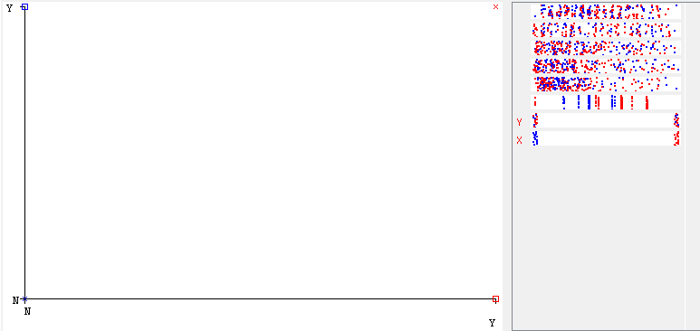

References

- Unav. (2008). Data Expo 2009: Airline on time data. Harvard Dataverse. https://doi.org/10.7910/dvn/hg7nv7
- Causes of Delays. (n.d.). In NBAA - National Business Aviation Association. Retrieved August 1, 2026, from https://nbaa.org/aircraft-operations/airspace/tfm/concepts/causes-of-delays/
- https://digital.ahrq.gov/health-it-tools-and-resources/evaluation-resources/workflow-assessment-health-it-toolkit/all-workflow-tools/decision-tree
- Bureau of Transportation Statistics. (2022). Understanding the Reporting of Causes of Flight Delays and Cancellations | Bureau of Transportation Statistics. In www.bts.gov. https://www.bts.gov/topics/airlines-and-airports/understanding-reporting-causes-flight-delays-and-cancellations

